GPS Module Interfacing with Arduino for Real-Time Location Tracking

Objective
The objective of this project is to interface a GPS module, receive real-time GPS data in NMEA format, decode latitude and longitude values, and verify the obtained location using Google Maps.
Components Used

GPS NEO-7M Satellite Positioning Module (Datasheet)
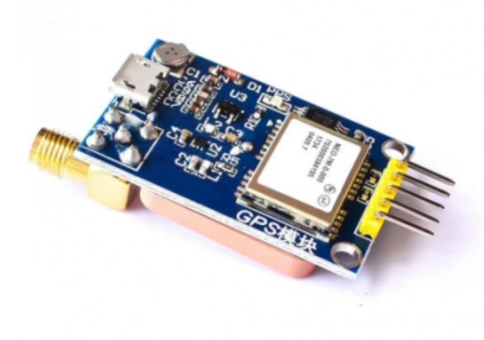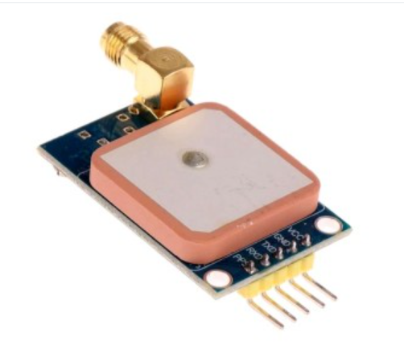
GPS Antenna
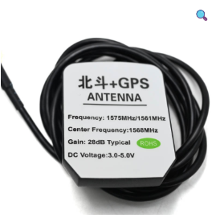
Connections to ftd1232
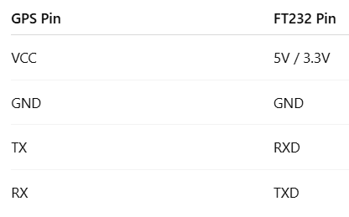

What are NMEA Sentences?
NMEA (National Marine Electronics Association) sentences are ASCII text strings sent by GPS modules over serial communication Eg - $GPRMC, $GPGGA, $GPGSV
Each sentence:
- Starts with $
- Fields are comma-separated
- Ends with a checksum (*XX)
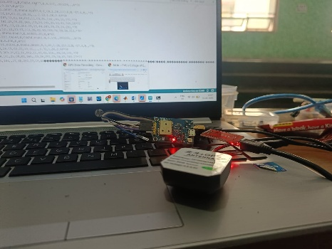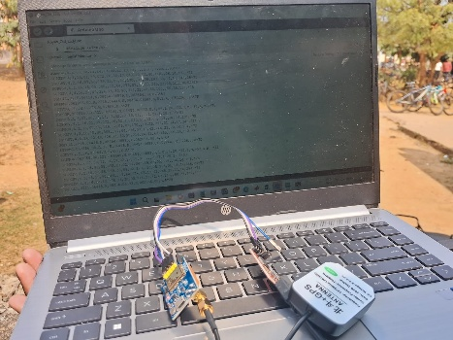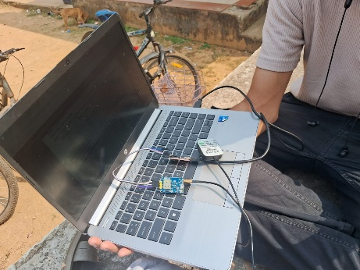
The GPS Coordinates on google maps showing that the results are accurate
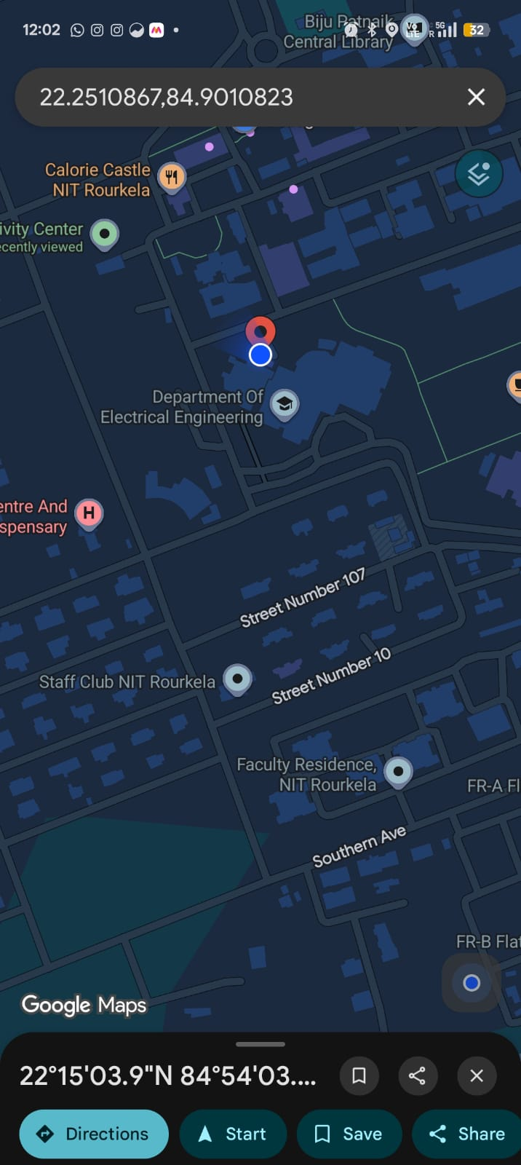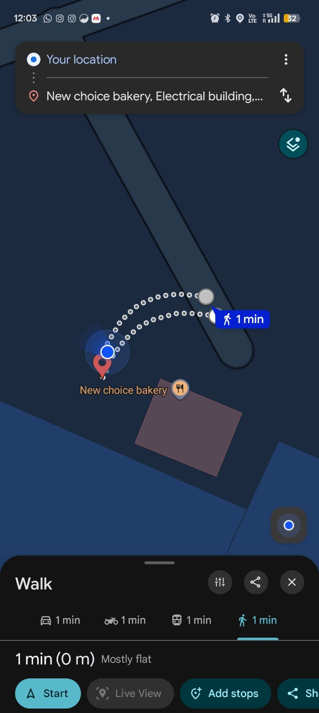

Output on Arduino IDE.
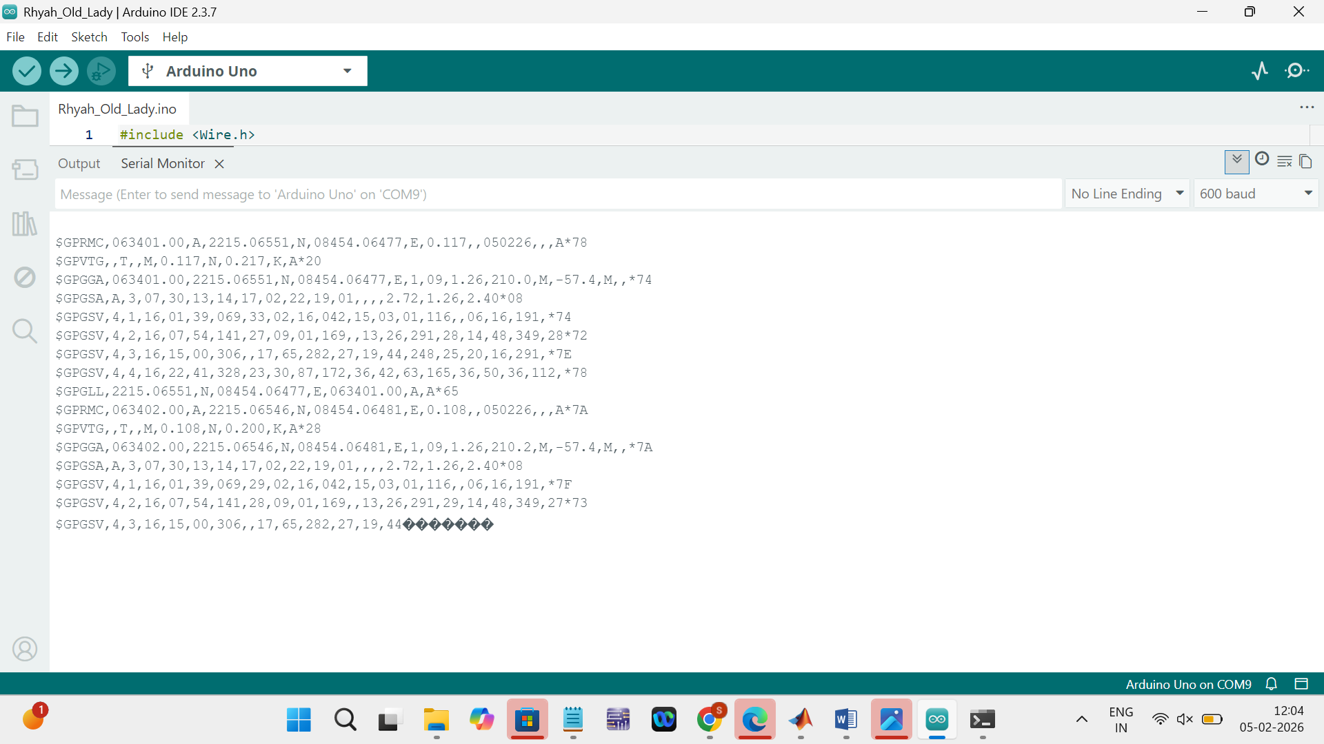

Latitude and Longitude calculation
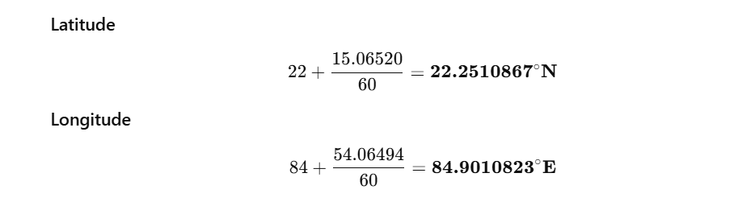
Interpretation of what the terminal output means
